Plotly Dash Lab
# Import required libraries
import pandas as pd
import dash
from dash import html
from dash import dcc
from dash.dependencies import Input, Output
import plotly.express as px

# Read the airline data into pandas dataframe
spacex_df = pd.read_csv("spacex_launch_dash.csv")
max_payload = spacex_df['Payload Mass (kg)'].max()
min_payload = spacex_df['Payload Mass (kg)'].min()

# Create a dash application
app = dash.Dash(__name__)

# Create an app layout
app.layout = html.Div(children=[html.H1('SpaceX Launch Records Dashboard',
style={'textAlign': 'center', 'color': '#503D36',
'font-size': 40}),
# TASK 1: Add a dropdown list to enable Launch Site selection
# The default select value is for ALL sites
dcc.Dropdown(id='site-dropdown',
options=[
{'label': 'All sites', 'value': 'ALL'},
{'label': 'CCAFS LC-40', 'value': 'CCAFS LC-40'},
{'label': 'CCAFS SLC-40', 'value': 'CCAFS SLC-40'},
{'label': 'KSC LC-39A', 'value': 'KSC LC-39A'},
{'label': 'VAFB SLC-4E', 'value': 'VAFB SLC-4E'},
],
value='ALL',
placeholder="Select a Launch Site here",
searchable=True),
html.Br(),

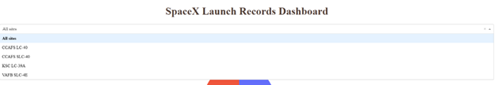

# TASK 2: Add a pie chart to show the total successful launches count for all sites
# If a specific launch site was selected, show the Success vs. Failed counts for the site
html.Div(dcc.Graph(id='success-pie-chart')),
html.Br(),

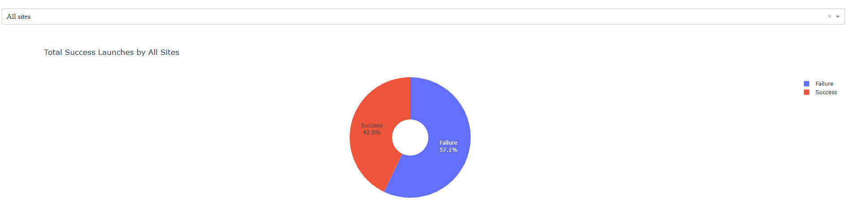

html.P("Payload range (Kg):"),
# TASK 3: Add a slider to select payload range
dcc.RangeSlider(id='payload-slider',
min=0,
max=10000,
step=1000,
marks={
0: '0 Kg',
2500: '2,500 kg',
5000: '5,000 kg',
7500: '7,500 kg',
10000: '10,000 kg',
},
value=[min_payload, max_payload],
),
html.Br(),
# TASK 4: Add a scatter chart to show the correlation between payload and launch success
html.Div(dcc.Graph(id='success-payload-scatter-chart')),
])
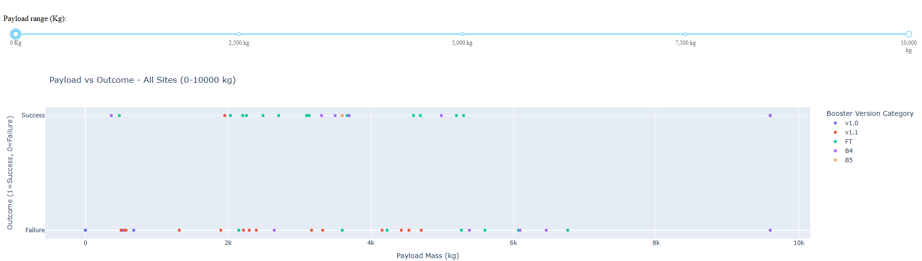
# TASK 2: Pie chart Callback
# Add a callback function for `site-dropdown` as input, `success-pie-chart` as output
@app.callback(
Output(component_id='success-pie-chart', component_property='figure'),
Input(component_id='site-dropdown', component_property='value')
)
def get_pie_chart(entered_site):
if entered_site == 'ALL':
df = spacex_df.copy()
title = 'Total Success Launches by All Sites'
else:
df = spacex_df[spacex_df['Launch Site'] == entered_site].copy()
title = f'Success vs Failure at {entered_site}'

df['Outcome'] = df['class'].map({0: 'Failure', 1: 'Success'})
fig = px.pie(df, names='Outcome', title=title, hole=0.3)
fig.update_traces(textinfo='percent+label')
return fig
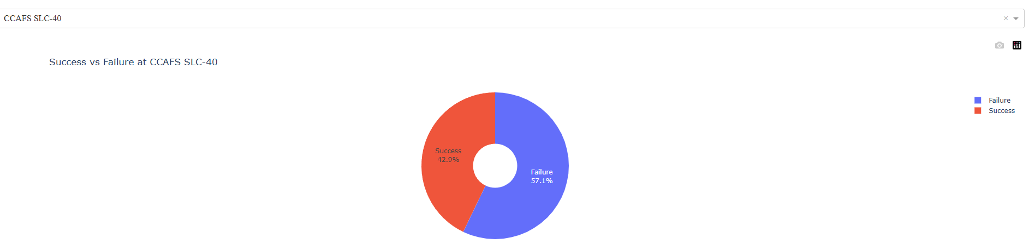
# TASK 4: Scatter Chart Callback
# Add a callback function for `site-dropdown` and `payload-slider` as inputs, `success-payload-scatter-chart` as output
@app.callback(
Output(component_id='success-payload-scatter-chart', component_property='figure'),
[
Input(component_id='site-dropdown', component_property='value'),
Input(component_id='payload-slider', component_property='value') # Fixed quote
]
)
def update_scatter(entered_site, payload_range):
low, high = payload_range

# Payload filter
mask = (spacex_df['Payload Mass (kg)'] >= low) & (spacex_df['Payload Mass (kg)'] <= high)
df = spacex_df[mask]

# Site filter
if entered_site == 'ALL':
plot_df = df
title = f'Payload vs Outcome - All Sites ({low}-{high} kg)'
else:
plot_df = df[df['Launch Site'] == entered_site]
title = f'Payload vs Outcome - {entered_site} ({low}-{high} kg)'
# Scatter plot
plot_df = plot_df.copy()
fig = px.scatter(
plot_df,
x='Payload Mass (kg)',
y='class',
color='Booster Version Category',
title=title,
labels={'class': 'Outcome (1=Success, 0=Failure)'},
hover_data=['Launch Site']
)
fig.update_yaxes(
tickvals=[0, 1],
ticktext=['Failure', 'Success']
)
return fig

# Run the app
if __name__ == '__main__':
app.run()

